What cereal is the best for diabetics?

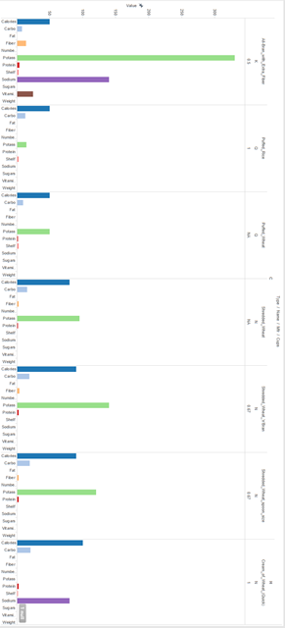

What group of cereals best assists your metabolism?

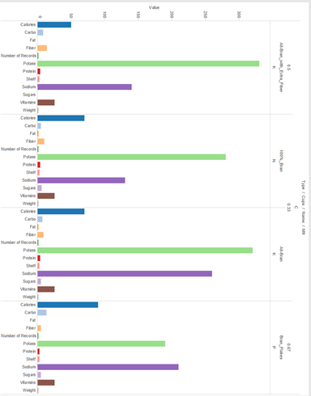

Is the serving size of a cereal correlated to the amount of calories it contains?

